Hyperbolic Spiral
# Source: AI Source: Provided by: [Data Path: Persons Table -> ID Column: 1, Name_En Column: Motasem Essam] -> From: [ChatGPT] on [7/25/2026]
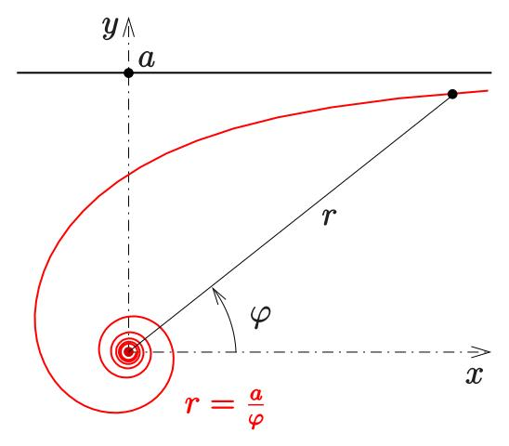
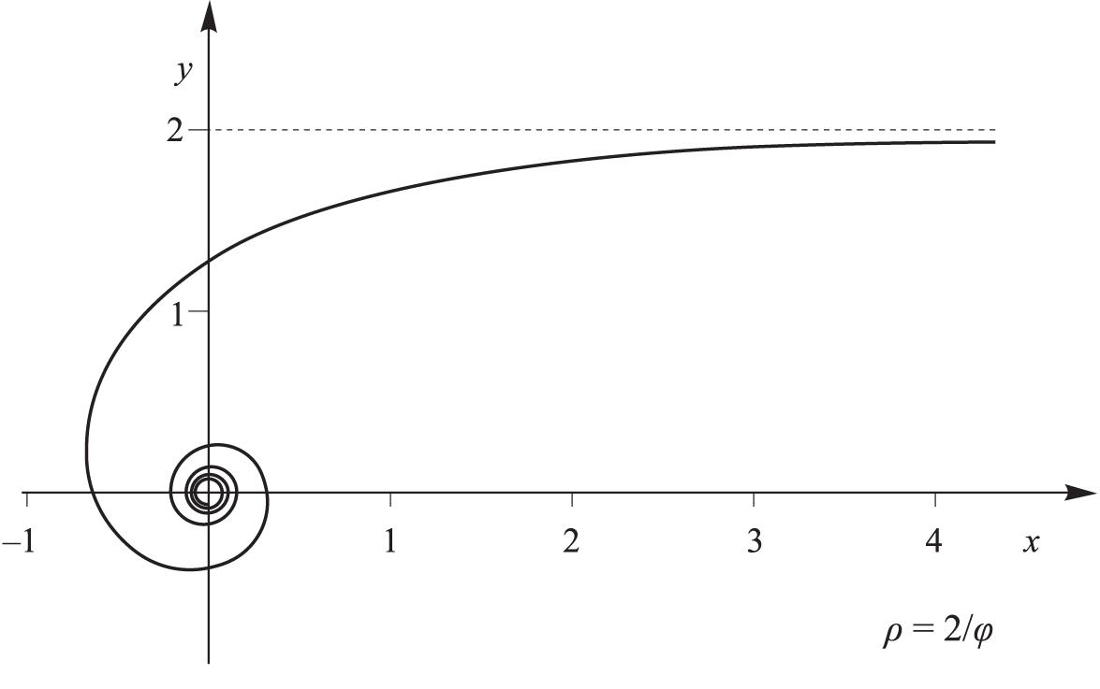
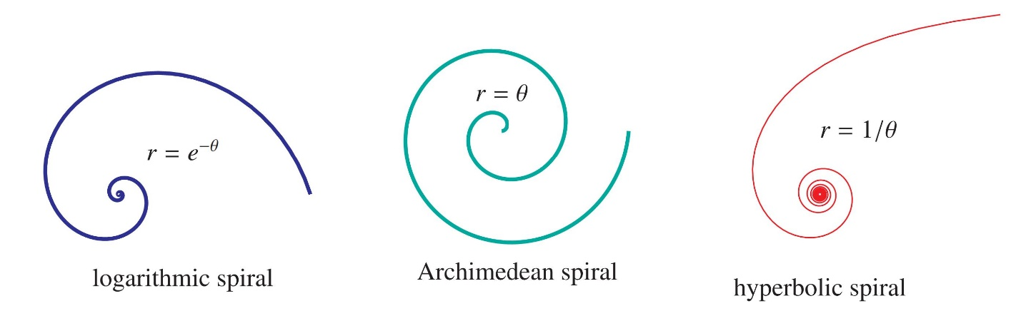

Definition
# Source: AI Source: Provided by: [Data Path: Persons Table -> ID Column: 1, Name_En Column: Motasem Essam] -> From: [ChatGPT] on [7/25/2026]
A Hyperbolic Spiral is a type of spiral whose radial distance from the pole decreases inversely as the angle increases.
Its standard polar equation is:
$$\boxed{r=\frac{a}{θ}}$$
where:
- $r$= radial distance from the pole
- $θ$= angular position
- $a$= constant controlling the scale and direction of the spiral
- $θ≠0$
The defining relationship is:
$$\boxed{rθ=a}$$
Therefore, as $θ$increases, $r$approaches zero.

Fundamental Concept
# Source: AI Source: Provided by: [Data Path: Persons Table -> ID Column: 1, Name_En Column: Motasem Essam] -> From: [ChatGPT] on [7/25/2026]
The Hyperbolic Spiral follows an inverse relationship between radius and angle:
$$r∝\frac{1}{θ}$$
For two points on the spiral:
$$r_{1}θ_{1}=r_{2}θ_{2}=a$$
Therefore:
$$\boxed{\frac{r_{1}}{r_{2}}=\frac{θ_{2}}{θ_{1}}}$$
This means that doubling the angle halves the radial distance.
Example
If:
$$r=\frac{12}{θ}$$
then:

$$θ$$ | $$r$$
$$1$$ | $$12$$
$$2$$ | $$6$$
$$3$$ | $$4$$
$$4$$ | $$3$$
$$6$$ | $$2$$
$$12$$ | $$1$$
The spiral moves progressively closer to the pole.

Basic Structure
# Source: AI Source: Provided by: [Data Path: Persons Table -> ID Column: 1, Name_En Column: Motasem Essam] -> From: [ChatGPT] on [7/25/2026]
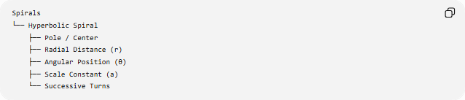
Spirals
└── Hyperbolic Spiral
├── Pole / Center
├── Radial Distance (r)
├── Angular Position (θ)
├── Scale Constant (a)
└── Successive Turns
The important relationship is:
$$\boxed{rθ=a}$$
Unlike an Archimedean Spiral, the radial distance does not increase linearly with the angle.

Standard Mathematical Representation
# Source: AI Source: Provided by: [Data Path: Persons Table -> ID Column: 1, Name_En Column: Motasem Essam] -> From: [ChatGPT] on [7/25/2026]
Polar Equation
$$\boxed{r=\frac{a}{θ}}$$
or equivalently:
$$\boxed{rθ=a}$$
This is the defining equation of the standard Hyperbolic Spiral.
Cartesian Parametric Form
Using:
$$x=r\cos{θ}$$
and
$$y=r\sin{θ}$$
we obtain:
$$\boxed{x=\frac{a\cos{θ}}{θ}} \\ \boxed{y=\frac{a\sin{θ}}{θ}}$$

Behavior of the Spiral
# Source: AI Source: Provided by: [Data Path: Persons Table -> ID Column: 1, Name_En Column: Motasem Essam] -> From: [ChatGPT] on [7/25/2026]
The derivative of the radius with respect to the angle is:
$$r=\frac{a}{θ}$$
so:
$$\boxed{\frac{dr}{dθ}=-\frac{a}{θ^{2}}}$$
For $a>0$and $θ>0$:
$$\frac{dr}{dθ}<0$$
Therefore, the radius decreases as the angle increases.
As $θ→∞$
$$\lim_{θ→∞}\frac{a}{θ}=0$$
Therefore:
$$\boxed{r→0}$$
The spiral approaches the pole.
However, it does so after continuing through an increasing number of rotations.

Radial Distance After One Revolution
# Source: AI Source: Provided by: [Data Path: Persons Table -> ID Column: 1, Name_En Column: Motasem Essam] -> From: [ChatGPT] on [7/25/2026]
One complete revolution corresponds to:
$$Δθ=2π$$
At angle $θ$:
$$r_{1}=\frac{a}{θ}$$
After one additional revolution:
$$r_{2}=\frac{a}{θ+2π}$$
Therefore:
$$\boxed{\frac{r_{2}}{r_{1}}=\frac{θ}{θ+2π}}$$
Unlike the Archimedean Spiral, the radial difference between successive turns is not constant.

Number of Turns
# Source: AI Source: Provided by: [Data Path: Persons Table -> ID Column: 1, Name_En Column: Motasem Essam] -> From: [ChatGPT] on [7/25/2026]
The number of complete turns over an angular interval is:
$$\boxed{N=\frac{Δθ}{2π}}$$
For example, if:
$$Δθ=6π$$
then:
$$N=\frac{6π}{2π}=3$$
So the curve makes three complete revolutions.

Arc Length
# Source: AI Source: Provided by: [Data Path: Persons Table -> ID Column: 1, Name_En Column: Motasem Essam] -> From: [ChatGPT] on [7/25/2026]
For a polar curve $r=f\left(θ\right)$, the arc length is:
$$L=\int_{θ_{1}}^{θ_{2}}{\sqrt{r^{2}+{\left(\frac{dr}{dθ}\right)}^{2}}} dθ$$
For:
$$r=\frac{a}{θ}$$
we have:
$$\frac{dr}{dθ}=-\frac{a}{θ^{2}}$$
Therefore:
$$L=\int_{θ_{1}}^{θ_{2}}{\sqrt{\frac{a^{2}}{θ^{2}}+\frac{a^{2}}{θ^{4}}}} dθ$$
which can be written as:
$$\boxed{L=∣a∣\int_{θ_{1}}^{θ_{2}}{\frac{\sqrt{θ^{2}+1}}{θ^{2}}} dθ}$$
For suitable positive-$θ$ intervals, an antiderivative is:
$$\boxed{L=∣a∣{\left[-\frac{\sqrt{θ^{2}+1}}{θ}+\ln\left(θ+\sqrt{θ^{2}+1}\right)\right]}_{θ_{1}}^{θ_{2}}}$$

Area in Polar Coordinates
# Source: AI Source: Provided by: [Data Path: Persons Table -> ID Column: 1, Name_En Column: Motasem Essam] -> From: [ChatGPT] on [7/25/2026]
The area swept between two angles is:
$$A=\frac{1}{2}\int_{θ_{1}}^{θ_{2}}{r^{2}} dθ$$
Substituting:
$$r=\frac{a}{θ}$$
gives:
$$A=\frac{1}{2}\int_{θ_{1}}^{θ_{2}}{\frac{a^{2}}{θ^{2}}} dθ$$
Therefore:
$$\boxed{A=\frac{a^{2}}{2}\left(\frac{1}{θ_{1}}-\frac{1}{θ_{2}}\right)}$$
for positive $θ_{1},θ_{2}$.

Important Properties
# Source: AI Source: Provided by: [Data Path: Persons Table -> ID Column: 1, Name_En Column: Motasem Essam] -> From: [ChatGPT] on [7/25/2026]
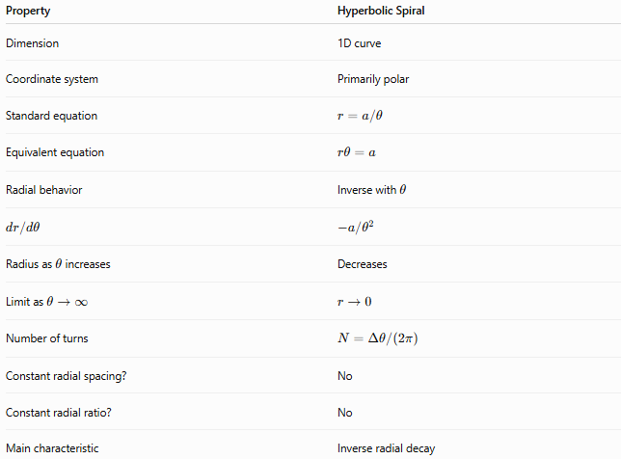
Property | Hyperbolic Spiral
Dimension | 1D curve
Coordinate system | Primarily polar
Standard equation | $$r=a/θ$$
Equivalent equation | $$rθ=a$$
Radial behavior | Inverse with $θ$
$$dr/dθ$$ | $$-a/θ^{2}$$
Radius as $θ$increases | Decreases
Limit as $θ→∞$ | $$r→0$$
Number of turns | $$N=Δθ/\left(2π\right)$$
Constant radial spacing? | No
Constant radial ratio? | No
Main characteristic | Inverse radial decay

Hyperbolic Spiral vs Other Spirals
# Source: AI Source: Provided by: [Data Path: Persons Table -> ID Column: 1, Name_En Column: Motasem Essam] -> From: [ChatGPT] on [7/25/2026]
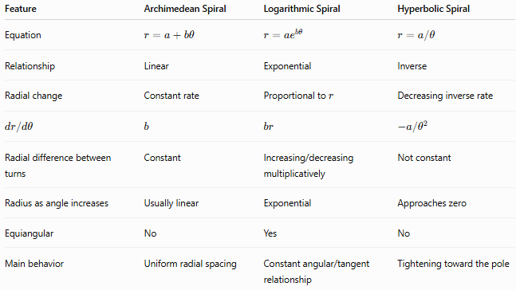
Feature | Archimedean Spiral | Logarithmic Spiral | Hyperbolic Spiral
Equation | $$r=a+bθ$$ | $$r=ae^{bθ}$$ | $$r=a/θ$$
Relationship | Linear | Exponential | Inverse
Radial change | Constant rate | Proportional to $r$ | Decreasing inverse rate
$$dr/dθ$$ | $$b$$ | $$br$$ | $$-a/θ^{2}$$
Radial difference between turns | Constant | Increasing/decreasing multiplicatively | Not constant
Radius as angle increases | Usually linear | Exponential | Approaches zero
Equiangular | No | Yes | No
Main behavior | Uniform radial spacing | Constant angular/tangent relationship | Tightening toward the pole

Example
# Source: AI Source: Provided by: [Data Path: Persons Table -> ID Column: 1, Name_En Column: Motasem Essam] -> From: [ChatGPT] on [7/25/2026]
Consider:
$$\boxed{r=\frac{20}{θ}}$$
At:
$$θ=2$$
the radius is:
$$r=\frac{20}{2}=10$$
At:
$$θ=4$$
the radius is:
$$r=\frac{20}{4}=5$$
At:
$$θ=10$$
the radius is:
$$r=\frac{20}{10}=2$$
Thus:
$$θ↑ ⟹ r↓$$
and eventually:
$$r→0$$

Important Distinction
# Source: AI Source: Provided by: [Data Path: Persons Table -> ID Column: 1, Name_En Column: Motasem Essam] -> From: [ChatGPT] on [7/25/2026]
The word hyperbolic refers to the inverse relationship:
$$\boxed{rθ=a}$$
It does not mean that the spiral itself is a hyperbola.
A hyperbola is a different type of curve with a different standard equation, such as:
$$\frac{x^{2}}{a^{2}}-\frac{y^{2}}{b^{2}}=1$$
The Hyperbolic Spiral is a spiral whose polar radius follows an inverse function of the angle.

Classification
# Source: AI Source: Provided by: [Data Path: Persons Table -> ID Column: 1, Name_En Column: Motasem Essam] -> From: [ChatGPT] on [7/25/2026]
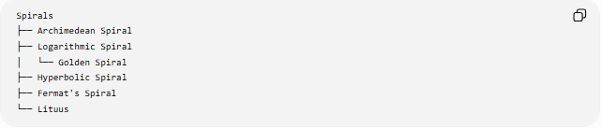
Spirals
├── Archimedean Spiral
├── Logarithmic Spiral
│ └── Golden Spiral
├── Hyperbolic Spiral
├── Fermat's Spiral
└── Lituus
Directional classification
The standard form
$$r=\frac{a}{θ}$$
describes the basic Hyperbolic Spiral. Depending on the chosen parameterization and interval, it may be described as an inward spiral because its radial distance approaches zero as $θ$increases.
“Inward Hyperbolic Spiral” is therefore a descriptive classification, rather than a separate fundamental spiral family.

Key Points
# Source: AI Source: Provided by: [Data Path: Persons Table -> ID Column: 1, Name_En Column: Motasem Essam] -> From: [ChatGPT] on [7/25/2026]
- A Hyperbolic Spiral is defined by an inverse relationship between $r$and $θ$.
- Its standard equation is:
$$\boxed{r=\frac{a}{θ}}$$
- Equivalently:
$$\boxed{rθ=a}$$
- As $θ$increases, $r$decreases.
- The spiral approaches the pole:
$$\boxed{\lim_{θ→∞}r=0}$$
- Its radial spacing between turns is not constant.
- It is different from the Archimedean Spiral, which has constant radial spacing.
- It is different from the Logarithmic Spiral, which has exponential radial behavior.
- The term “hyperbolic” describes the inverse mathematical relationship, not a hyperbola-shaped boundary.

Conclusion
# Source: AI Source: Provided by: [Data Path: Persons Table -> ID Column: 1, Name_En Column: Motasem Essam] -> From: [ChatGPT] on [7/25/2026]
A Hyperbolic Spiral is a spiral whose radius is inversely proportional to its angular position:
$$\boxed{r=\frac{a}{θ}}$$
As the angle increases, the radial distance decreases and the curve winds progressively closer to the pole. Its defining feature is the inverse relationship
$$\boxed{rθ=a}$$
which distinguishes it from the linear growth of the Archimedean Spiral and the exponential growth or decay of the Logarithmic Spiral.

